Software Design Document

*for*

ETHIIC Client

COPYRIGHT 2014VCortex Ltd ©

This document contains valuable and confidential information proprietary to VCortex Ltd. The recipient of this document shall not disclose its contents, in whole or in part, to any third party without VCortex’ prior written approval.

|  |  |  |
| --- | --- | --- |
| *Version* | *Date* | *Description* |
| 1 | Mar 15, 2015 | Basic version |

Contents

1. General 3

1.1. Scope 3

1.2. Overview 3

2. Source Files 4

3. Mode of operation 4

3.1. GUI Design 4

3.2. Device init 5

3.3. Write and read one byte 5

3.4. Send bytes 5

3.5. Receive bytes 5

3.6. Wakeup II 5

3.7. Burst test for Stratsys device 5

3.8. Test IIC bus with EEPROM 5

# General

## Scope

This document describes the testing application called ETHIIC Client that was developed for the ETHIIC module. The ETHIIC client runs on the host computer and connects to the ETHIIC DLL.

## Overview

The ETHIIC (Ethernet Integrated InterCom) is a bridge that converts Ethernet communication to I2C communication, to enable SW running on the main computer to control I2C controlled devices.

The ETHIIC is a partial implementation of the IOX (IO Extender module) that includes some more interfaces implementation. The GPIO and IIC are fully implemented in the ETHIIC board, as a derivative of the IOX module.

The ETHIIC can be connected as a single or multiple configuration, controlled by host computer through UDP commands. Therefore, the ETHIIC module bears a unique logical name, unique IP and unique MAC address.

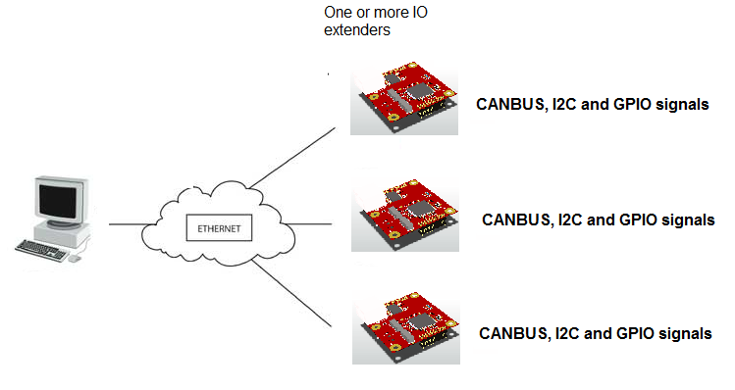

Figure : IOX multiple board configuration

# Source Files

Following table describes the source files of the ETHIIC Client:

|  |  |
| --- | --- |
| File | Description |
| Form1.h | Definition of one page GUI |
| ETHIIC_Client.cpp | Main function for the client, that starts the GUI form |

# Mode of operation

## GUI Design

The ETHIIC Client displays the following page:

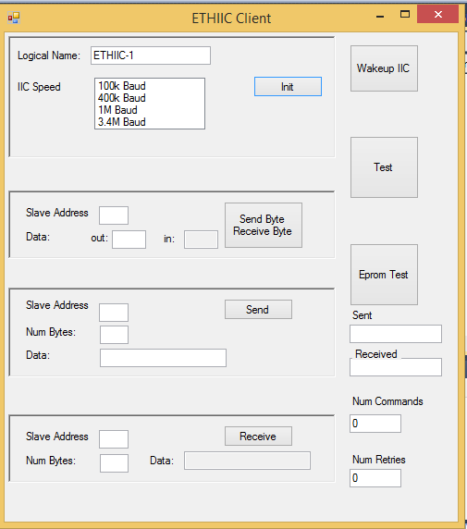

## Device init

Before hitting the INIT button, make sure that Logical Name and IIC Speed are set.

Hitting the Init button calls the IOX_initDevice() and IOX_initIIC() functions.

## Write and read one byte

Fill the slave address, and the value to write in the “out” text box. Note: both values are decimal.

Then hit “Send Byte Receive Byte” button. Provided a device by the specified slave address is connected to the ETHIIC device, a result byte will be displayed in the “in” text box.

## Send bytes

Fill the slave address, num of bytes and the data to be sent.

Note: slave address and num bytes are decimal values. The data is ASCHII string.

When “Send” button is selected, the data is sent to the I2C slave.

## Receive bytes

Fill the slave address, and num of bytes.

Note: slave address and num bytes are decimal values.

When “Receive” button is selected, the received data is displayed on the “data” text box.

## Wakeup II

Hitting “Wakeup IIC” button causes call to IOX_wakeupIIC() with the current slave. This causes special wakeup sequence to be applied on the I2C bus wires.

## Burst test for Stratsys device

This test is applied when hitting the “Test” button.

The test include 1000 times of the following sequence:

* Send 0x01, 0x20 to address 112
* Send 0x46, 0x00, 0x00, 0x46 to address 95
* Send 0x00, 0x00 to address 112

The completion time for the above loop is displayed on the “num commands” text box.

If retries occurred, num of retries is displayed on the “num retries” text box.

## Test IIC bus with EEPROM

This test operates with Atmel EEPROM of the type 24C256 (<http://www.atmel.com/Images/doc0670.pdf> ) connected to the ETHIIC module.

When hitting “Test EEPROM” button, following steps are taken:

* Do XXX times:
  + Build a list of 100 random numbers
  + Burn the list into the EEPROM
  + Read the list from the EEPROM
  + Compare values